**TECHNICAL REPORT ON STUDENTS INDUSTRIAL WORK EXPEREINCE SCHEME (SIWES)**

**AT**

**AFABROS COMPUTER COLLEGE,**

**MUBI, ADAMAWA STATE**

**FROM: 4TH JANUARY, 2023**

**TO: 4TH MAY, 2023**

**BY**

**EMMANUEL LEVI**

**ST/CS/ND/21/143**

**Submitted to the department of computer science, school of science and technology, federal polytechinic mubi**

**JUNE, 2023**

**CERTIFICATION**

This is to certify that this report compiled by EMMANUEL LEVI with the registration number **ST/CS/ND/21/143** meets the regulation governing the award of the national Diploma in computer science, the federal polytechnic Mubi, Adamawa state and approved by

………………………………………. ………………………

EMMANUEL LEVI DATE

(STUDENT)

………………………………………. ………………………

(MR . SIMON GALADIMA) DATE

DEPARTMENTAL SIWES COORDINATOR

………………………………………. ………………………

MR. ADAMU GARBA DATE

(HEAD OF DEPARTMENT)

**DEDICATION**

I dedicate this technical report to God Almighty for His ultimate protection and divide guidance protection throughout the four (4) months of this industrial training program.

**ACKNOWEDGEMENTS**

My gratitude goes to God for His wonderful love and protection upon my life during the SIWES program and to my beloved family and friends for their prayer and support.

It will not be complete if I do not appreciate the head of the department of computer science (Mr. Simon Galadima), my supervisor and all my lecturers in the department of computer science

I also want to acknowledge the industry base supervisor (Engr. Mathias Afariyu)

Where I did my SIWES program and I also want to thank him for fatherly advice and words of encouragement, time, teaching and supervising my logbook.

I thank my colleagues whom in one way or the order have contributed to the success of the SIWES program.

**ABSTRACT**

*This contain information of the various activities that has been carried out during the four month mandatory student industrial work experience scheme (SIWES) in Afabros computer collage. The report consist of the four (4) chapters the first contains information about SIWES, importance and objective of SIWES. Chapter two contain description of the organization where I was attached, location /history and objectives. Chapter three contains of activities acquired during the IT and the last chapter which is chapter four consist of summary, recommendation, conclusion and reference.*

**TABLE OF CONTENTS**

TITLE PAGE - - - - - - - - - - i

DEDICATION- - - - - - - - - - ii

ACKNOWLEDGEMENT- - - - - - - - - iii

ABSTRACT - - - - - - - - - - - iv

TABLE OF CONTENT- - - - - - - - - v

**CHAPTEER ONE**

1.0 INTRODUCTION- - - - - - - - - 1

1.1 AIM OF SIWES- - - - - - - - - - 1

1.2 OBJECTIVES- - - - - - - - - - 1

**CHAPTER TWO**

2.0 DESCRIPTION OF AFABROS COMPUTER COLLEGE - - - 2

2.1 LOCATION AND BRIEF HISTORY OF AFABROS COMPUTER COLLEG - 2

2.2 OBJECTIVE OF AFABROS COMPUTER TRAINING - - - 3

**CHAPTER THREE**

3.0 ACTIVITIES I UNDERTOOK DURING MY TRAINING AT AFABROS COMPUTER COLLEGE, MUBI

3.1 MICROSOFT EXCEL- - - - - - - - - 12

3.2 I LEARNT SOME BASIC OPERTATION SIGNS THAT ARE USED IN MICROSOFT EXCEL AND HOW THERE ARE USE- - - - - - - 13

3.3 MICROSOFT WORD- - - - - - - - - 14

3.4 I LEARNT KEYBOARD SHORTCUT KEYS IN MICROSOFT WORD - 14

3.5 I LEARNT HOW TO SAVE A FILE AS PDF IN MICROSOFT WORD - 16

3.6 NOTEPAD- - - - - - - - - - 17

3.7 I LEARNT HOW TO LUNCH A NOTEPAD AND HOW TO CREAT A SIMPLE TABLE THEN TYPE THE FOLLOWING - - - - - - 18

I LEARNT ABOUT INTERNET- - - - - - - - 18

3.8 I LEARNT THE MEANING OF SOME HTML TAGS - - - - 19

**CHAPTER FOUR**

SUMMARY- - - - - - - - - - - 20

CONCULSION- - - - - - - - - - 20

RECOMMENDATION- - - - - - - - - 21

REFERENCE- - - - - - - - - - 22

**CHAPTER ONE**

**1.0 INTRODUCTION**

The acronym (SIWES) which stand for “student Work experience scheme” is a practical training program designed to offer student the great opportunity to use the best equipment with the practical aspect of their development knowledge. The training which last for four (4) month was a necessity to all student in institution of higher learning, most importantly to those in polytechnic, universities of technology as it from part of higher national diploma, bachelor Degrees in science and technology. It help student to be familiar with handling equipment, crucial to work methods at the end of the training so that upon graduation he/she is practically fit for jobs relevant to his/her discipline

**1.1 AIM OF SIWES**

To provide student with the opportunities to apply their educational knowledge in real work situations, there by bridging the gap between theory and practice. It also enlist and strengthen employer’s involvement in the entire educational process through SIWES.

**1.2 OBJECTIVE OF SIWES**

1. To developed student practical knowledge in the perspective of their field of studies
2. To create job opportunity for student after their graduation
3. To create an avenue for student to share their idea and skill with other people in the society.
4. It is a mean of destiny, career, goal, and provision of working experience prior graduation.
5. It create gap between skill and unskilled people in the society
6. To prepare and expose student situation outside the academic environment

**CHAPTER TWO**

**2.0 DESCRIPTION OF AFABROS COMPUTER COLLEGE MUBI**

Afabros Computer College Mubi is registered computer company incorporated under the companies and allied Matter Act 1990 with an RCR No. 012949 and CERT No. YLZ000304 and SERIAL NUMBER 1238084, and is wholly indigenous company. The company is multidisciplinary with specialization /bias in computer training (Engineering, repairs, software development, web design, networking), sales of computer, and secretarial service

**VISION**

To led in the provision of information technology and communication technology (ICT) service and specialization in the industrial and entrepreneurial graduate for development of the society.

**MISSION**

To build more proactive ICT company and offer an improved level of service to all clients.

To provide the best cost-effective service and solution

**2.1 LOCATION AND BRIEF HISTORY OF AFABROS COMPUTER COLLEGE**

Afabros Computer College is a private computer college, located in Mubi north local government of Adamawa state Nigeria. It was established in 2003 as computer center and was called “Afabros computers”, where people came to type, print and a few students for computer training.

The company laid emphasis on job quality, truthfulness, accountability, dynamism and satisfaction at all, time. As people that have vision, the staff spent most of their time in their office trying to finish all task to satisfy the needs of the students .beside the students and their sponsor are always satisfied with the outcome of the training. These gave the Afabros a good name which is the above every other name in computing, and now tagged,

“AFABROS was tried was tested, and now trusted”

The company which started with one personal computer, now has well over 50 working computer and three (3) department namely: computer/Electronics Engineering Department, computer science Department and a secretarial Department. Afabros Computer College has now graduated over 5000 students as of 2021. Students from college of Education, federal and state polytechnics, federal and state Universities all come to Afabros Computer College yearly for their student industrial working Experience Scheme (SIWES) programs. People from neighboring countries such as Republic of Chad and Cameroon are many in Afabros Computer College.

Afabros Computer College actively encourages entrepreneurship by his students. Most business-oriented graduates are now self-employed such as Start Best Computer Uba, Borno State, Celesmac Computer Federal Polytechnic Mubi signabobo company Ltd. (Njamena, Chad Republic), among others.

**2.2 OBJECTIVE OF AFABROS COMPUTER COLLEGE TRAINING**

Afabros Computer College has been producing majority middle-level manpower that has been making valuable contribution to the social and economic development of Africa and the world at large. The objective of the college are:

1. To revolutionize the Afabros computer’s operation in line with dynamic of the operation environment
2. To commit to operational excellence and long-term thinking thereby education students on computer usage
3. To strengthen the Afabros brand, leverage and upscale the customers’ and students’ experience usage
4. To project Afabros computer college as sophisticated and dynamic

HEAD

COMPUTER SCIENCE DEPEARTMENT

HEAD

SECRETARIAL DEPARTMENT

**LABORATORY ATTENDENT**

**PRODUCTION MANAGER**

HEAD

ENGINEERING DEPARTMENT

**COMPUTOR OPERATOR**

CLEANER

SECURITY

SE

POWER MANAGER

ACADEMICE SECRETARY

DIRECTOR OF STUDENT

ORGANIZATIONAL CHART AFABROS COMPUTER COLLEGE MUBI

SIWES COORDINATOR

**CHAPTER THREE**

**3.0 ACTIVITIES I UNDERTOOK DURING MY TRIANING AT AFABROS COMPUTER COLLEGE, MUBI**

During the SIWES program I was opportune to have been introduced to the following programs: Microsoft word, Microsoft Access, Microsoft excel Microsoft power point Microsoft publisher, web design using HTML and hardware maintaince

**3.1 MICROSOFT EXCEL**

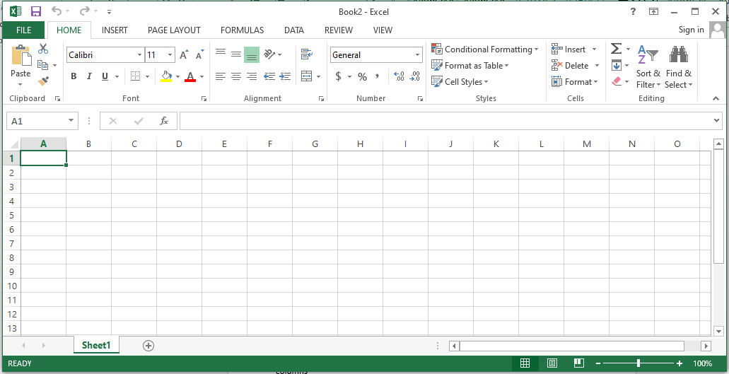

Figure 3.1: Microsoft excel 2013 interface

Definition of Microsoft excel: this spreadsheet that manipulate date in row and columns

ROW: this run from left to right across the window and it position is designated by numbers

FILL HANDLE: a small back square at the lower corner of the selected cell

NAME BOX: this display the name of the selected cell or range cell

**I LEARNT SOME BASIC OPERTATION SIGNS THAT ARE USED IN MICROSOFT EXCEL AND HOW THERE ARE USE:**

1. equality sign =
2. exponent sing ^
3. Division /
4. additiion +
5. subtraction ­-

**HOW TO CACULATE SUM**

We use sum when calculating addition in excel. And before spreadsheet can respond to any mathematical command. It must be entered as an equation. Therefore, to enter a function as an equation. We must firstly start with ‘‘equals to’’ (=) sign.

Steps in calculating sum:

1. Firstly, the data must be entered correctly as shown below
2. Then keep your cursor on the location you want sum to be displayed by clicking the mouse there
3. Type =sum and open bracket ‘‘(then, click the mouse on the first cell you want to sum now type : click mouse on the last cell containing the data to be sum
4. Then close the bracket )
5. Press enter on the keyboard.

EXAMPLE

I learnt how in insert pie in micro soft excel

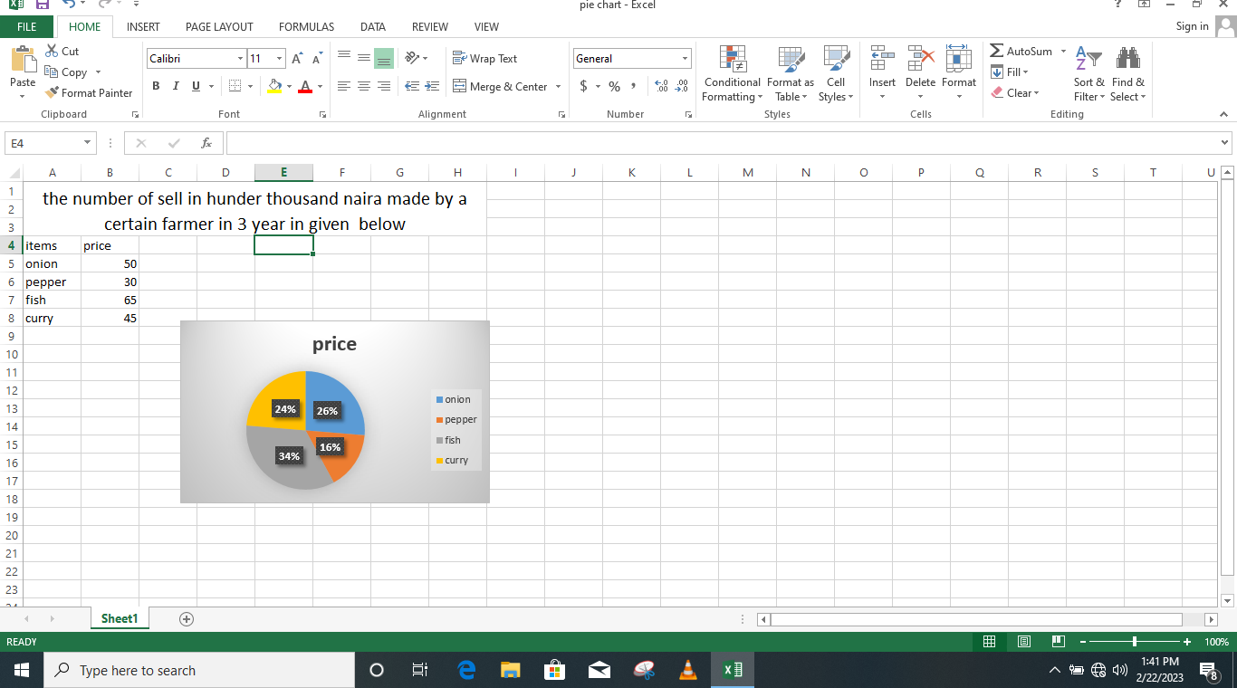

**3.2 MICROSOFT WORD**

Microsoft is an application package that allows one to type, edit and retrieve a typed document. It is used to create beautiful document, typing of letters time tables, design report form and insertion of image to a document you have typed.

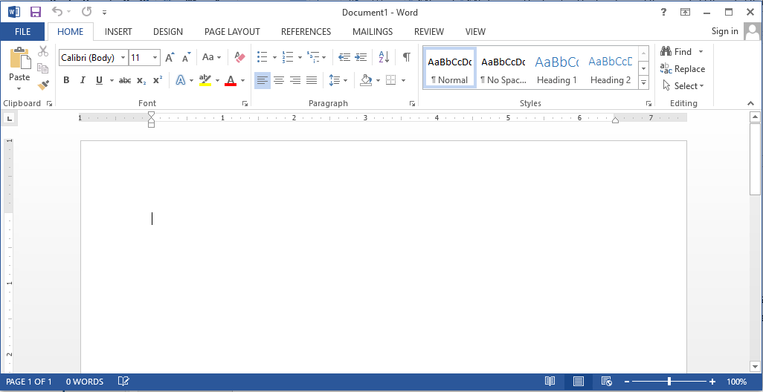

Figure 3.2: Microsoft word interface

**I LEARNT KEYBOARD SHORTCUT IN MIRCOSOFT WORD**

The keyboard shortcut keys are:

Control +A =select all

Control+ B = turn bold on or off

Control + C = copy selected object

Control + D = duplicate selected object

Control + E = center alignment of a selected paragraph

Control + F = find missing or hidden text

Control + G = go to specific page

Control + H = find and replace missing text or hidden text

Control + I = italicize selected text

Control + J = justify selected paragraph

Control + K =insert hyperlink

Control + L = left align of a selected paragraph

Control + M = left indent

Control + N = new blank document

Control + O =

Control + P = print dialog box

Control + Q = format paragraph

Control + R = right align of selected paragraph

Control + S = save dialog box

Control + T = hang intent

Control + U = under line selected paragraph

Control + V = past object after begin copied or cut

Control + W = close a file especially in Microsoft word

Control + X = cut selected text or object

Control + Y = redo last action

Control+ Y = undo last action

**3.2.1 I LEARNT HOW TO SAVE A FILE AS PDF IN MICROSOFT WORD**

Step1: open the file

Step2: click file on the menu bar

Step3: click save as

Step4: below the file name you will see

Step5: save as type

Step6: select PDF

Step7: save

**3.3 NOTEPAD**

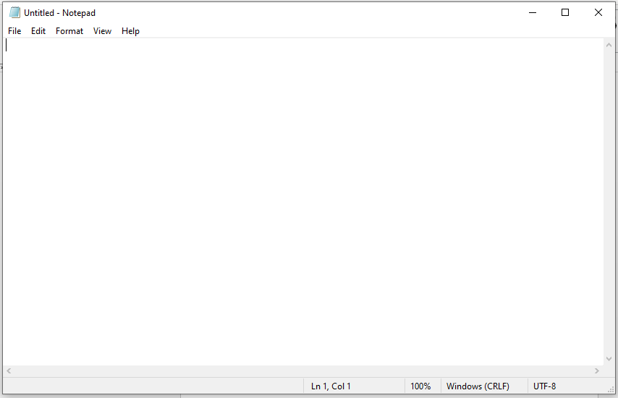

Figure 3.3: Notepad interface

**3.2.1 I LEARNT HOW TO LUNCH A NOTEPAD AND HOW TO CREAT A SIMPLE TABLE**

Start

All programs

Accessories

Notepad

**Then Type the following:**

<html>

<table border=1>

<td>serial number</td>

<td>name</td>

<td>registration number</td>

<td>course of study</td>

<tr>

<td>1</td>

<td> Hosea victor </td>

<td>ST/CS/ND/21/140</td>

<td>computer science </td>

<tr>

<td>2</td>

<td>Alhamdu Musa</td>

<td>ST/CS/ND/21/124</td>

<td>computer science </td>

<tr>

<td>3</td>

<td>Emmanuel Levi</td>

<td>ST/CS/ND/21/143</td>

<td>computer science</td>

<tr>

<td>4</td>

<td>Isaac Moses</td>

<td>ST/CS/ND/21/002</td>

<td>computer science </td>

<tr>

<td>5</td>

<td>Emmanuel James</td>

<td>ST/CS/ND/21/140</td>

<td>computer science</td>

<tr>

<td>6</td>

<td>Buhari Musa</td>

<td>ST/CS/ND/21/002</td>

<td>computer science </td>

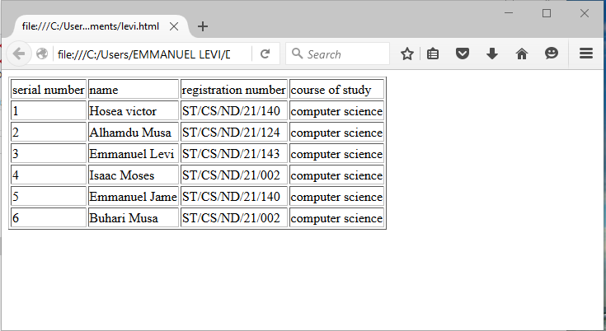

**3.3.2 I LEARNT THE MEANING OF SOME HTML TAGS**

<Opening tag

>closing tag

<br>break a line</br>

<b> to make bold</b>

<u> to underline</u>

**3.3.3 THE INTERNET**

Internet is the global networks of computers. On the internet, millions of computer are connected together so that the could share files and information. You can link your computer to the internet anywhere you are in the world through any of the following items:

Dial up connection:- this dial up connection is the slowest means of accessing internet. Example of dial up connection is through telephone cable. If you use the dial up connection, you cannot connect to the internet and talk on the internet at the same time. Unless you have a second phone line.

1. ISDN (integrated service ditital network):- is a telephone line which carries digital signal at higher speed than Dial-up connection. CD-Audio quality sound and superior video conferencing images coluld be transmitted through ISDN. It requires a telephone company to install the connectors.
2. DSL (Digital Subscriber Line):- also uses the existing telephone lines but the signal is split at the entry point to the home or office building,so DSL coming into the computer doesn’t share the regular phone line connection to use DSL you must located within 20,000 feet of the telephone switching station ,,, ssso DSL is most common in the urban area
3. Cable : csble connection to the internet require using a television cable systems
4. Satellite : in remote place where DSL or cable is not possible , you can use the satellite connection to internet. A small satellite dish at your home sends the signal to the satellite that bounces the signal to another dish at your service provider network center
5. TI: TI line and the faster T3 lines use high speed dedicate phone trunk line that would normaly carry multiple telephone line. They are generally usaed by the government agencies , cooperatives and educational institution that have many user connecting at one time

There is confusion between internet and World Wide Web (3w or www) internet is the HARDWARE that connect the computer network world wide . ythe internet server as a pipeline for FTP ( file transfer protocol), electronic mail, useNet news the,and www etc . how ever www is service which easy access to the internet’s wealth of information.its primary function is to connect, link and related information.

Web page is a page you read on the internet using a web browser. Web page can contain text , graphics, animation , video and sound Web page can include dyamic element which change or update continually. Web page can contain hyperlinkers. Web sit is 2 or more related web pages.portal site is a web site which offers a varity of service , include searching capabilities . portal site allow you to choose what is display on the page , giving a dynamic personalized feel to the site. For this reason , many people will chose a portal site as their home page . Every time they lunch their browser , they willsee all the lastest information customized to their preferences. Exmple of portal site are :Yahoo, www.yahoo.com, google ,www.google.com,Microsoft , [www.microsoft.com](http://www.microsoft.com) etc

**I LEARNT HOW TO DOWNLOAD A FILE FROM INTERNET**

1. Click start on the taskbar
2. Click **google Chrome** (or the installed browser)
3. On the **address bar** , type the criteria , e.g **how to locate ground water** , and press **Enter** on the keyboard.,

**I LEARNT HOW TO SEND ATTACHMENT**

The steps are :

1. Log into your account
2. Click on cpmpose
3. Write to
4. Subject
5. Write what you want to send to the person
6. Click attache file
7. It open the folder &select the file you want
8. Click send and finally
9. enter

**CHAPTER FOUR**

**4.1 Summary**

The technical report is an account of work done, knowledge acquired and an experience gained by the student during SIWES program with afro computer collage . the report consist of the model , procedures and result of work carried out and the experience acquired in practical atttachment with the above named establishment the work done have been catergorised into four chapter

**4.2 CONCLUSION**

The stuent industrial Work Experience Scheme (SIWES) is a good program that exposes students to their various field of the studies and helps student to known more of the practical aspect in the various discipline

**4.3 RECOMMENDATION**

I recommend that the private and public organization should join hands with ITF by allowing student to observe their industrial training the establihmentin the order to get more knowledge in their field.

**REFERENCE**

1. Training log book ( from 4th January to 31st april 2023)
2. Mathias Afariyu lecture notes